**Mongo DB=>**

**# 3 ways to work with mongo DB**

1.Compass App - GUI tool.

2.VS code extension.

3.Through command shell

Step1 => Navigate to mongo DB bin folder path

C:\Program Files\MongoDB\Server\4.4\bin>.\mongo.exe

run the command .\mongo.exe

--------------------------------------------------------------------

**-> Commands through command shell.**

**\*TO show all databases**

show databases

**\* Show currently running database.**

db

**\*TO Create-**

use <database name>

**\*TO Drop Databases-**

db.dropDatabase()

**\*Creating and dropping collections**

db.createCollection(name, options)

db.collection.drop()

-----------------------------------------------------------------------

**\*Data types in mongo DB**

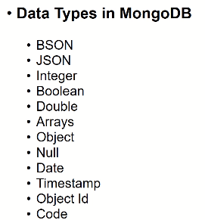

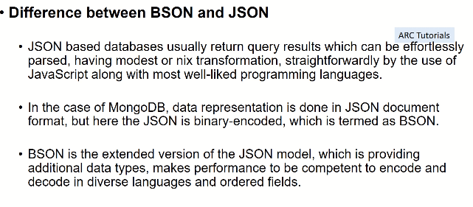

* **What is BSON?**MongoDB data type
* Store and progress data
* Binary encoded JSON – BSON => and it has some extended data types which are not supported by JSON. Below are the examples.  
  => date  
  => timestamp

=> object ID

* **Document Insertion in Mongo DB collection**
  + - **db.collectionName.insert()**
    - **db.collectionName.insertMany()**-We can insert any number of documents into the collection.

-Every document we insert will have a unique key “_id”

- The Value for this key is always unique and 24 character

- _id as a primary key in your collection

**-Can we change the value of _id?**

**Ans** -Yes, we can change it but it is not a good practice.

* **Update Existing Document in a Collections.  
    
  -update()**

**-updateOne()  
-updateMany()**  
  
**Structure=>**  
databasename.collectionName.update(

{condition}, {value to set})

Example:   
**Database Name = Inventory**  
**Collection Name = users**  
  
Inventory.users.update(

{“name”: “jaydeep”},

{

$set: {

“isActive”: “true”,

“mobile” : “9067211658”

})

* **Reading Data from collection.**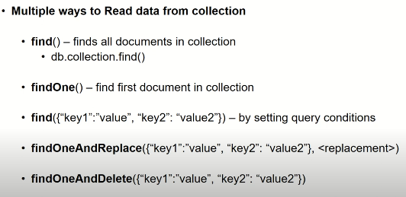

* **Delete Documents from Collection  
    
    
  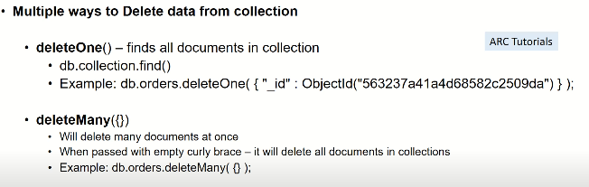**
* **Queries in MongoDB**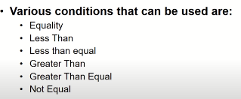  
  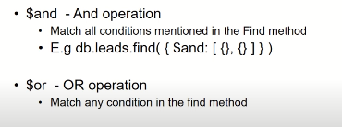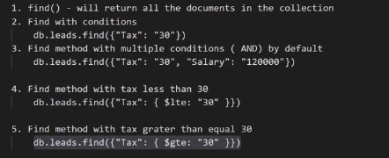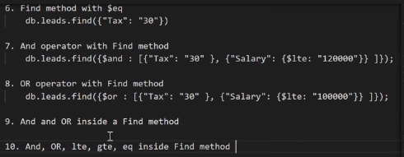
* **Find Specific Fields in MongoDB  
    
  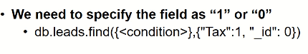**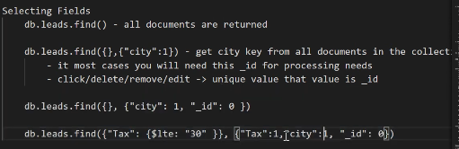
* **Projection In mongo DB**  
  -By Default it will bring up all keys/value s from all documents in collections  
  -Drill it down  
   db.leads.find({“Tax”:30)}  
    
  -number of documents will reduce  
   -60 keys  
   -We do not need all keys   
   We need only few keys   
    
  **For Example** => 1. SELECT * FROM “table” SQL/RDBMS  
   2. Find() => All documents.  
    
   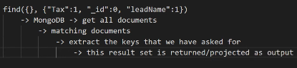
* **Aggregation  
    
  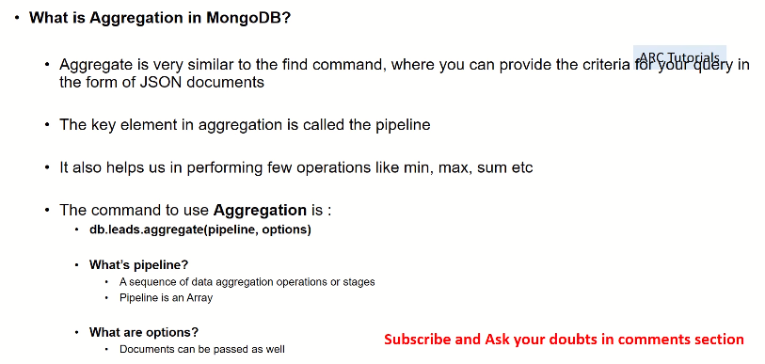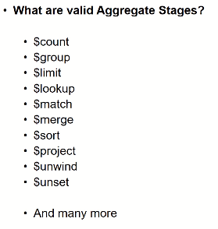**  
    
  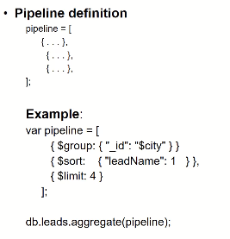
* **Limit and Skip**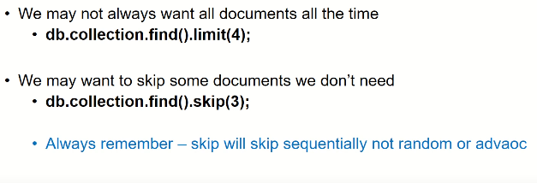
* **Sorting In MongoDB**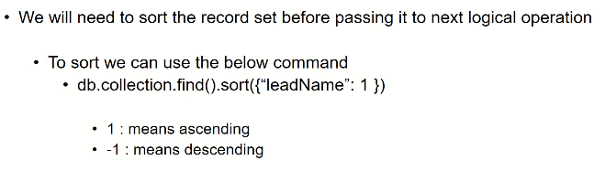
* **Creating Indexes  
  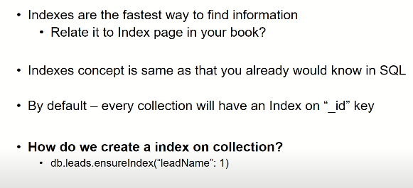**
* **Back Up and Restore**